# Z Transform and its Applications

# Objectives

The z-transform is a useful tool in the analysis of discrete-time signals and systems and is the discrete time counterpart of the Laplace transform for continuous-time signals and systems. The z-transform may be used to solve constant coefficient difference equations, evaluate the response of a linear time-invariant system to a given input, and design linear filters. In this lab, we will look at the z-transform and examine how it may be used to solve a variety of different problems.

As compared with Fourier Transforms, there are two shortcomings to the Fourier transform approach. First, there are many useful signals in practice— such as u(n) and nu(n)—for which the discrete-time Fourier transform does not exist. Second, the transient response of a system due to initial conditions or due to changing inputs cannot be computed using the discrete-time Fourier transform approach. Therefore we now consider an extension of the discrete-time Fourier transform to address these two problems. This extension is called the z-transform. Its bilateral (or two-sided) version provides another domain in which a larger class of sequences and systems can be analyzed, and its unilateral (or one-sided) version can be used to obtain system responses with initial conditions or changing inputs.

## Background Review

However in order for any system or signal series to converge, it is necessary that the signal be absolutely summable. Unfortunately, many of the signals that we would like to consider are not absolutely summable and, therefore, do not have a DTFT. Some examples include



The z-transform is a generalization of the DTFT that allows one to deal with such sequences. The ztransform G(z) of a sequence g[n] is defined as

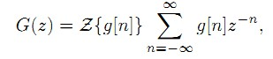

Where z= rejω is a complex variable.

The inverse z-transform of a complex function X(z) is given by



where C is a **counterclockwise** contour encircling the origin and lying in the ROC.

## Properties and Comments

1. The complex variable z is called the complex frequency given by z = |z|ejω, where |z| is the magnitude and ω is the real frequency
2. The values of z for which the sum converges define a region in the z-plane referred to as the region of convergence (ROC). The z-transform may be viewed as the DTFT of an exponentially weighted sequence.



1. In the case of LTI discrete-time systems, all pertinent z-transforms are rational functions of z−1, that is, they are ratios of two polynomials in z−1:



Which can be alternately written in factored form as

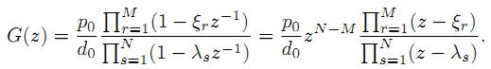

The roots of the numerator polynomial, ξr, are referred to as the zeros of X(z), and the roots of the denominator polynomial, λs, are referred to as the poles. There are additional N − M zeros at z=0 (the origin in the z-plane) if N>M or additional M − N poles at z=0 if N<M.

For a sequence with a rational z-transform, the ROC of the z-transform cannot contain any poles and bounded by the poles.A rational z-transform G(z)= P(z) /D(z) , where the degree of the polynomial P(z) is M and the degree of the polynomial D(z) is N, and with distinct poles at z=λs,s=1 ,2 ,...,N, can be expressed in a partial-fraction expansion form given by

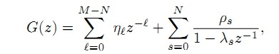

## Pole-zero plots

The poles and zeros are collectively termed the singularities of H(z). We can indicate the singularities of H(z) graphically on the z-plane as a pole-zero plot, denoting the poles with an X and zeros with an O.

## Left Side and Right Side Sequence

Sequences such as those shown below in figure are examples of right-sided sequences. A sequence h[n] is said to be right-sided if there exists some time n0 such that h[n] = 0, n < n0. The ROC of a right-sided sequence is always the exterior of a circle bounded by a pole. The ROC of H(z) has to be the exterior of a circle of radius r0, since this region includes all values of r > r0

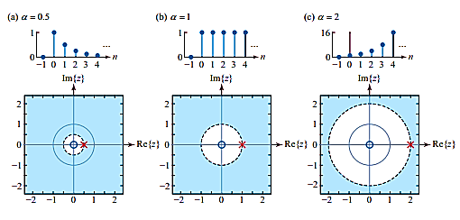

The cases shown below are said to be left-sided sequences since they are anti-causal; that is, there exists some time n0 such that h[n] = 0, n > n0. A left-sided impulse response might appear to be a mathematical curiosity since it would seem to be unrealizable

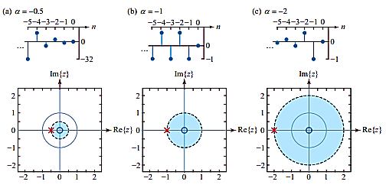

## Convolution



This property transforms the time-domain convolution operation into a multiplication between two functions. It is a significant property in many ways. First, if X1(z) and X2(z) are two polynomials, then their product can be implemented using the conv function in MATLAB.

### Task 1 Warm Up Question

### . Solve the following convolution problem



## The Zplane

MATLAB function roots on both the numerator and the denominator polynomials. (Its inverse function poly determines polynomial coefficients from its roots, as discussed in the previous section.) It is also possible to use MATLAB to plot these roots for a visual display of a pole-zero plot. The function zplane(b,a) plots poles and zeros, given the numerator row vector b and the denominator row vector a. As before, the symbol o represents a zero and the symbol x represents a pole. The plot includes the unit circle for reference. Similarly, zplane(z,p) plots the zeros in column vector z and the poles in column vector p. Note very carefully the form of the input arguments for the proper use of this function.

### Task 2 Given a causal system determine H(z) and sketch its pole-zero plot

*Part a Warmup Question*



The difference equation can be put in the form

y(n) − 0.9y(n − 1) = x(n)

or using equation



Use MATLAB to analyses result

**>> b = [1, 0];**

**a = [1, -0.9];**

**zplane(b,a)**

Questions

1. What does a and b and a represent
2. Is system casual, Explain the reason

*Part b : Problem*



## C. Residues and Poles

A MATLAB function **residuez** is available to compute the residue part and the direct (or polynomial) terms of a rational function in z−1. Let

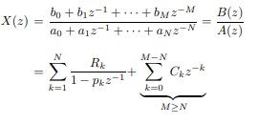

The **[R,p,C]=residuez(b,a)** computes the residues, poles, and direct terms of X(z) in which two polynomials B(z) and A(z) are given in two vectors b and a, respectively. The returned column vector R contains the residues, column vector p contains the pole locations, and row vector C contains the direct terms

Similarly, **[b,a]=residuez(R,p,C),** with three input arguments and two output arguments, converts the partial fraction expansion back to polynomials with coefficients in row vectors b and a

### Task 3 Using residue command solve the rational Z transform

#### **Warm Up Question**

To check our residue calculations, let us consider the rational function



**Matlab Code**

**>> b = [0,1]; a = [3,-4,1];**

**[R,p,C] = residuez(b,a)**

R = 0.5000 -0.5000 p = 1.0000 0.3333 c = []

Or We can write the above obtained values as



Similarly, to convert back to the rational function form

**>> [b,a] = residuez(R,p,C)**

It will give us

b = 0.0000  
 0.3333

a = 1.0000   
 -1.3333   
 0.3333

Which can be written as





### Question 1: Analyzing results obtained from residue Matlab Command

Repeat the same procedure as above for the equation given in task. However replace the 3z2 with 5z3

1. What is the value of R and P
2. What is C. What does it represent?

Direct terms of partial fraction are represented by C.

1. Write down the equation using value of RP? $X\left(z\right)$
2. Convert back to the rational function form

**D. Computing Right Side and Left hand Side Sequences**

#### Question 2 :

**D.1 Resolving Partial Fractions**

|  |
| --- |
| **Use poly command to find the roots** |

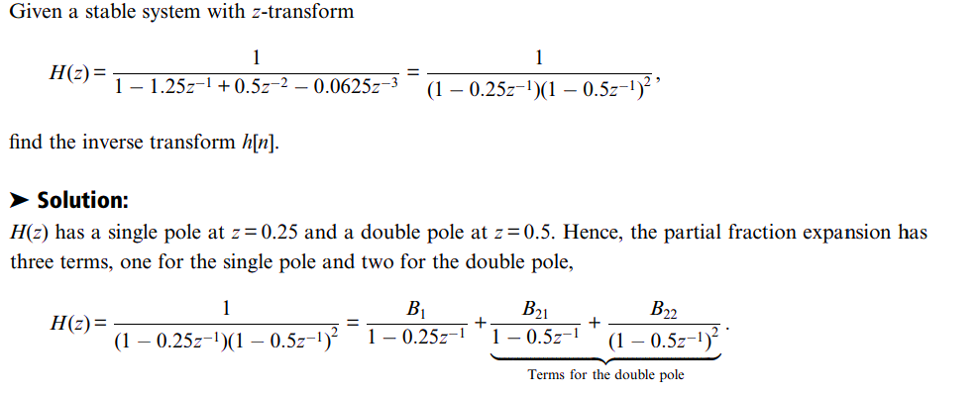

**D.2 Resolving Improper fractions**

The preceding discussion of the partial fraction method assumes that H(z) is a proper rational function of z -1 , where the order M of the numerator polynomial N(z), expressed in powers of z -1 , is less than the order N of the denominator polynomial D(z). When M > N, we can always apply long division to express H(z) as the sum of the direct terms of a simple polynomial in z -1 plus a proper rational function:

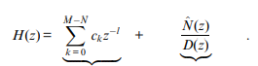

Lets now try to solve the following give task

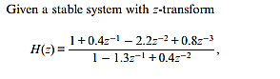

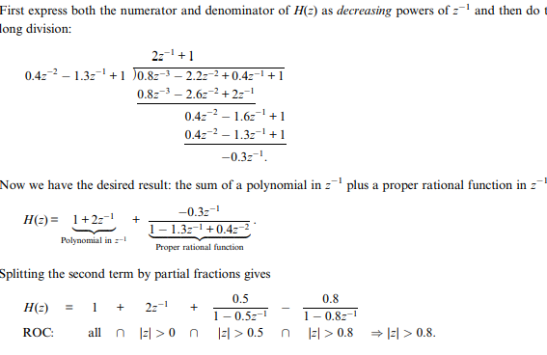

### D.3 Task 4 Now solve the following problem using the above same technique

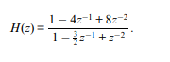

**Let Matlab do all the work.**

Recognize there are at most two kinds of terms in the partial fraction expansion of the inverse transform of H(z). Since the system comprises both left-sided and right-sided terms and is also stable, the ROC is an annulus that includes the value of |z| = 1. The right-sided terms of H(z) comprise all the direct terms plus those terms whose poles have absolute values less than one. The left-sided terms comprise the terms whose poles have absolute values greater than one. We can use Matlab to collect each of these sets of terms into a system whose impulse response we can determine computationally using residuez.

|  |
| --- |
| N = 10; ROCval = 1;  [r, p, k ]= residuez( [5 -26 39.5 -23.5 8 -2 ], [1 -5 8.5 -6 2 ]);  indx = (abs(p)< ROCval); % find right-sided terms  [br, ar ] = residuez(r(indx), p(indx), k); % find right-sided coeffs  rhs = filter(br, ar, [1 zeros(1, N-1) ]); % right-side  [bl, al ] = residuez(r(~indx), p(~indx), []); % find left-sided coeffs  lhs = fliplr(filter(bl(end:-1:1), al(end:-1:1), [1 zeros(1, N-2) ]));  stem(-n:n, [lhs rhs ]) |

#### **Task 4**

Solve and analyze using the using function for D.1 D.2 D.3

# Lab 8 : Inverse Z transform

The inverse z-transform computation requires an evaluation of a complex contour integral that, in general, is a complicated procedure. The most practical approach is to use the partial fraction expansion method. The z-transform, however, must be a rational function. This requirement is generally satisfied in digital signal processing.

**Central Idea**

When X(z) is a rational function of z−1, it can be expressed as a sum of simple factors using the partial fraction expansion. The individual sequences corresponding to these factors can then be written down using the z-transform table. The inverse z-transform procedure can be summarized as follows:



Which can be expressed as

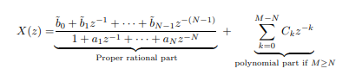

where the first term on the right-hand side is the proper rational part, and the second term is the polynomial (finite-length) part. This can be obtained by performing polynomial division if M ≥ N using the deconv function

where pk is the kth pole of X(z) and Rk is the residue at pk. It is assumed that the poles are distinct for which the residues are given by



For repeated poles the expansion has a more general form. If a pole pk has multiplicity r, then its expansion is given by



where the residues Rkl are computed using a more general formula, which is available in reference [23]. Assuming distinct poles we can write x(n) as

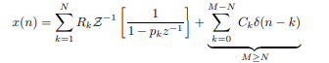

### Solving inverse Z transform using transform

### Task 1

### Warmup

Let the function in Z domain is:

$$X(z)=\frac{2z}{2z-1}$$

**Analyse the result**

**syms z n**

**iztrans(2*z/(2*z-1))**

### Problem 1 : Compute Z transform using residuez Command

Compute inverse z transform and provide the final results



### Verifying inverse Z transform using matlab

### Task 2 Problem 1

Determine the inverse z-transform of



Compute the inverse z transform and provide the final results. Use the two following additional commands to your result

**>>Mp=(abs(p))’ % pole magnitudes**

**>> Ap=(angle(p))’/pi % pole angles in pi units**

**Questions**

1. What is R P C
2. What is Mp and Mp

## System Representation in Z domain

### Task 3

### Warmup

Lets say we have a system and we want to analyze zero poles .

$$X(z)=\frac{1-1.6180z^{-1}+z^{-2}}{1-1.5161z^{-1}+0.878z^{-2}}$$

n**=[1 -1.6180 1]; % same as bs in Difference Eqn. model**

**d=[1 -1.5161 0.878]; % same as as in Difference Eqn. model**

**roots(d) % Poles of the function**

**roots(n) % Zeroes of the function**

**zplane(n,d) % generates pole-zero diagram of the function**

**pzmap(n,d)**

1. Discuss The results of above program
2. What Does the Graph Represent?
3. What does following command do . Add comments to the code, and discuss the result. What does SOS command do

**[z,p,k]=tf2zpk(n,d)**

**[sos k]= zp2sos(z,p,k)**

**zplane(z,p)**

# Post lab Exercise

1. Find the inverse z-transform of the following transfer function
$$Y(z)=\frac{1}{(1+z^{-1})(1-z^{-1})^{2}}$$

2. Find out the inverse z – Transform of the following function?
$$X(z)=\frac{6-9z^{-1}}{1-2.5z^{-1}+z^{-2}}$$

3. Determine the Z-transform of 10 cos 2n

1. Given is the system function of a DT LTI system

**num = [2 4 8 5 2];**

**den = [2 36 3 2 1];**

Find z p k . Now Use the following command

**SoS = zp2sos(z, p, k)**

1. What does SOS represent
2. Plot the zero-pole diagram for:

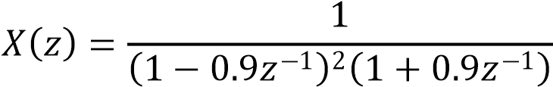, 

1. A causal, linear, and time-invariant system is given by the following difference equation:



Find the system function H (z) for this system.

Plot the poles and zeros of H (z) and indicate the region of convergence (ROC).

Find the unit sample response h (n) of this system.